3) Perform basic Image Handling and processing operations on
the image
AIM:-Read an image in python and Convert an Image
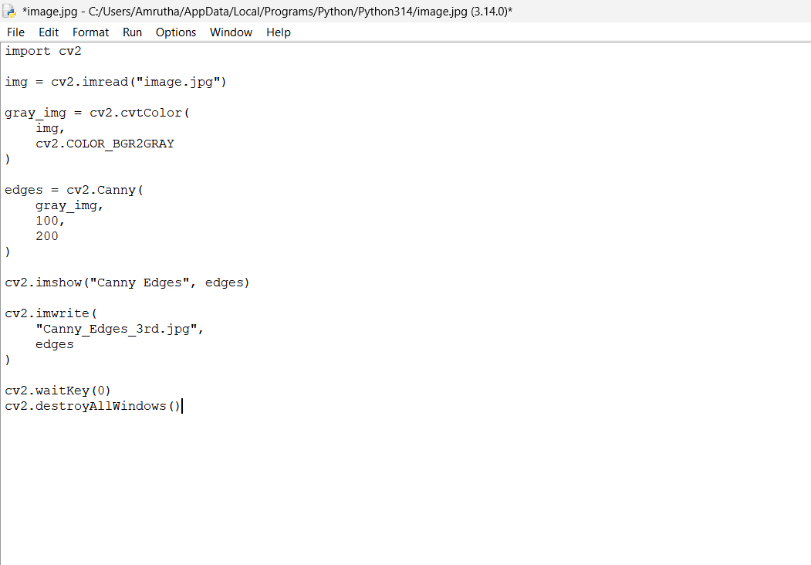
OUTPUT
